|  |
| --- |
| **IT Project** |
| Synoptic Assignment – Section A Version Control |
| Checkpoint 2 – Cloning of a GitHub repository using GitKraken  By Matthew De Giorgio BAN 6.3A |
|  |

Contents

Preface 1

Step 1 2

Step 2 3

Step 3 4

Step 4 5

Step 5 6

# Preface

With Gitkraken, it is a default option during repo initialisation to clone the repo locally. For this assignment, this option was disabled to allow for the facilitation of the process in case a user is cloning a pre-existing repository.

# Step 1

Launch Gitkraken.

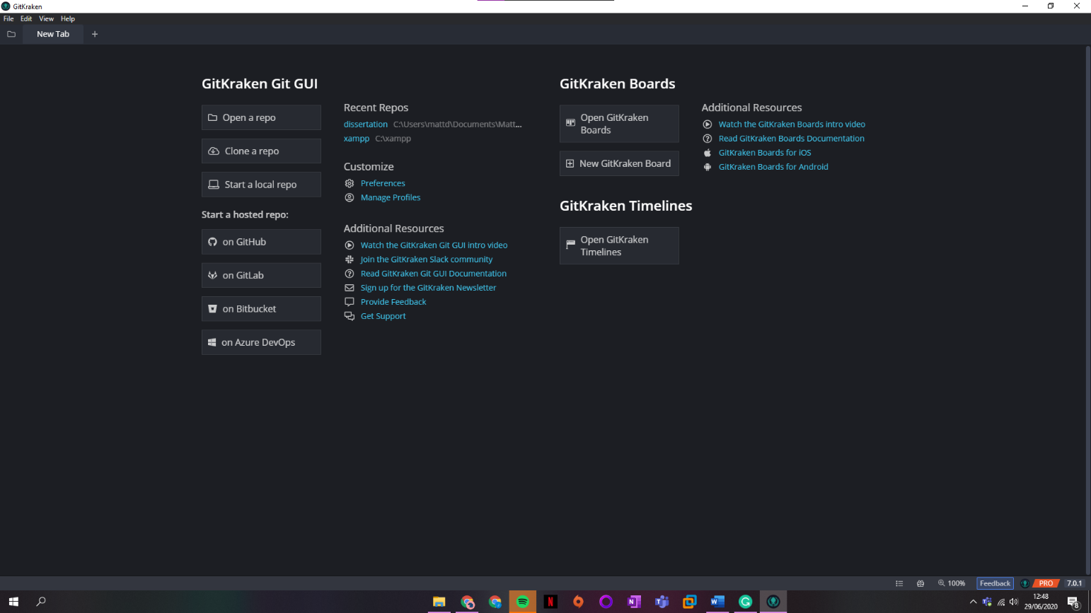

# Step 2

From the default launch tab, select the **Clone a Repo** button.

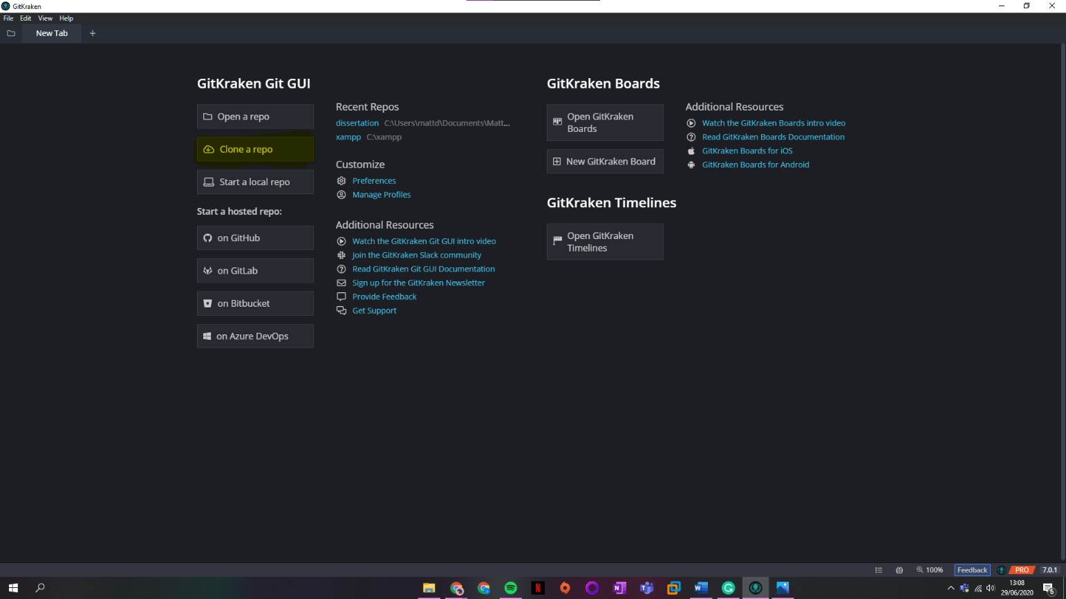

# Step 3

The **Repository** **Management** menu will come to appear with a different selection of menus and options.

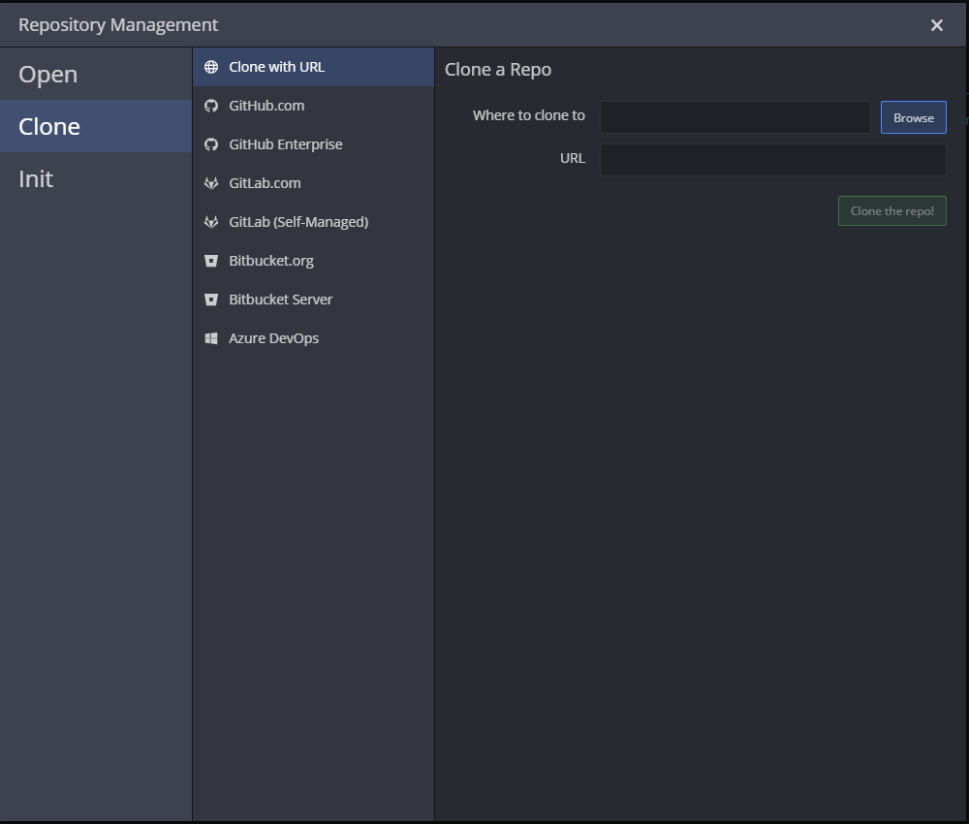

# Step 4

Fill in the required fields and select the appropriate options.

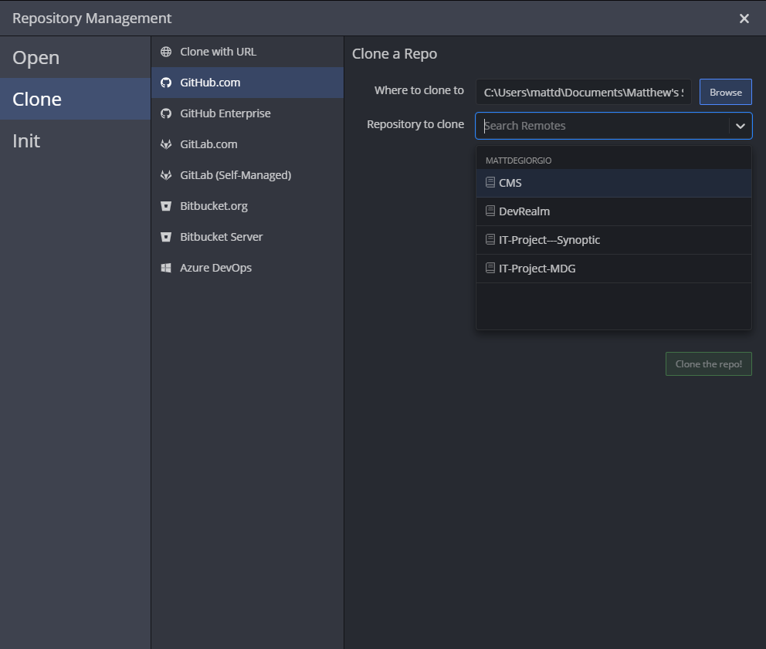

# Step 5

Upon completion, a successful completion **message** will come upon the interface.

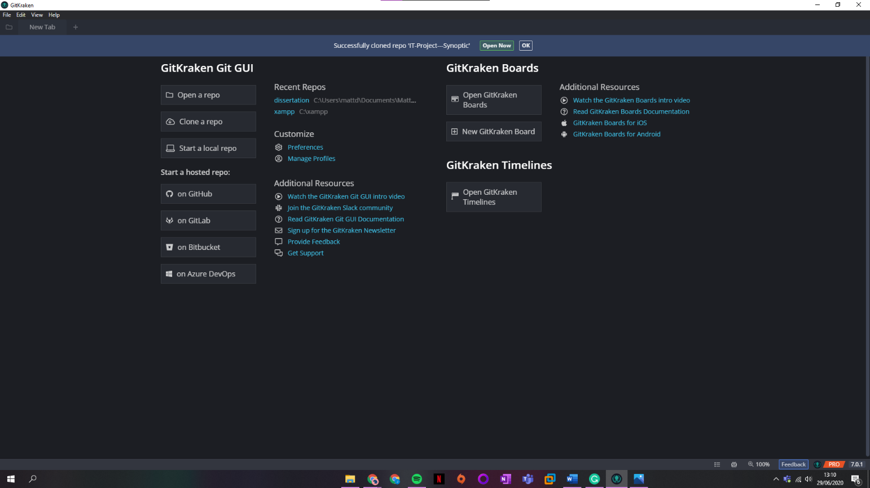

Followed by a message to make an initial commit.

